CS 255 System Design Document

UML Diagrams

UML Use Case Diagram
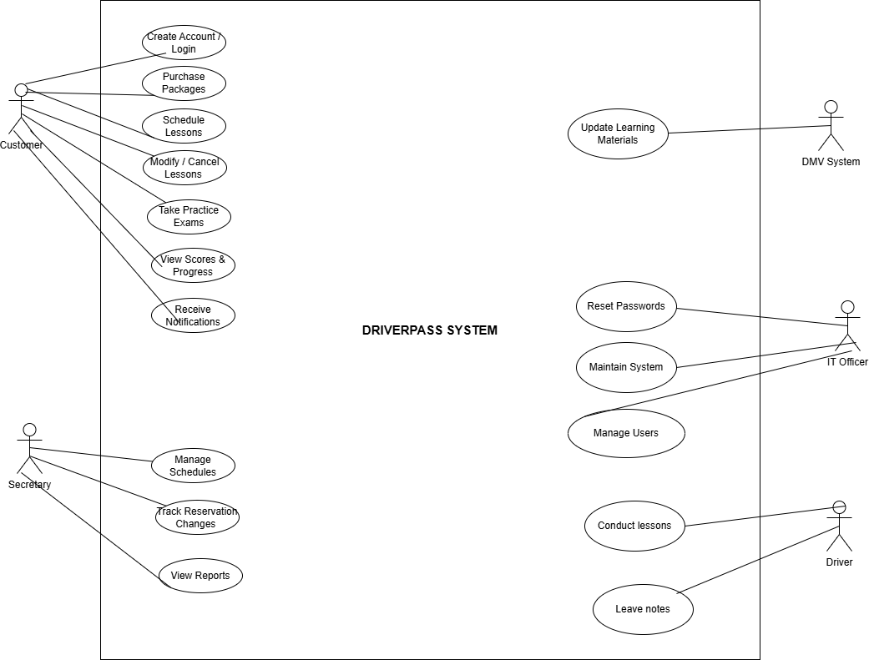

UML Activity Diagrams

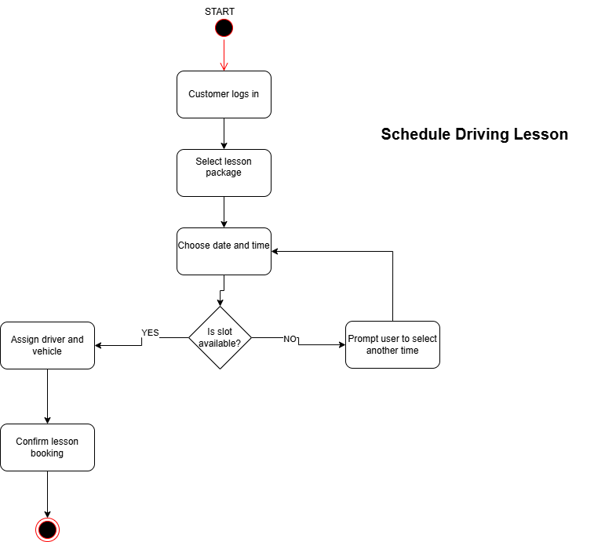

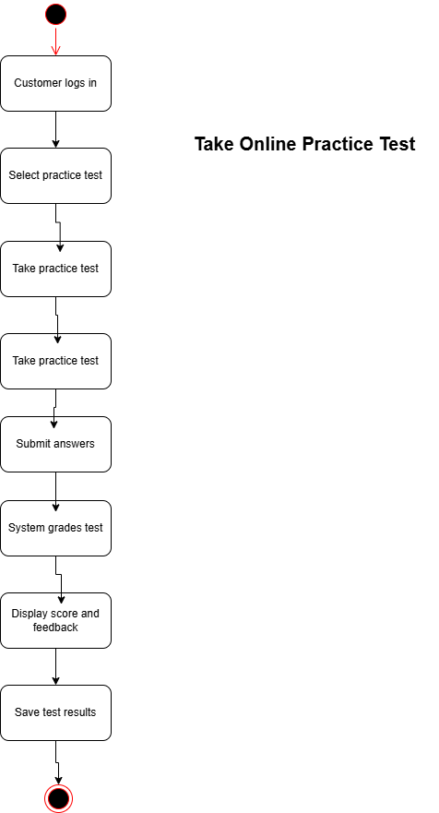

UML Sequence Diagram
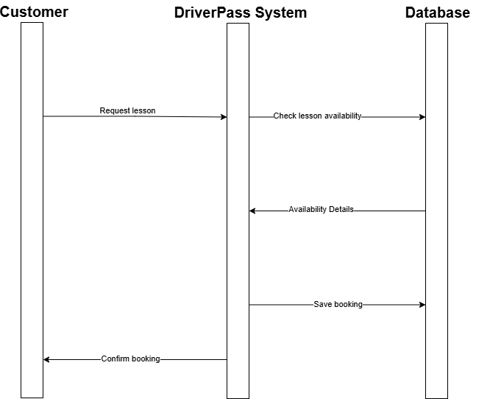

UML Class Diagram
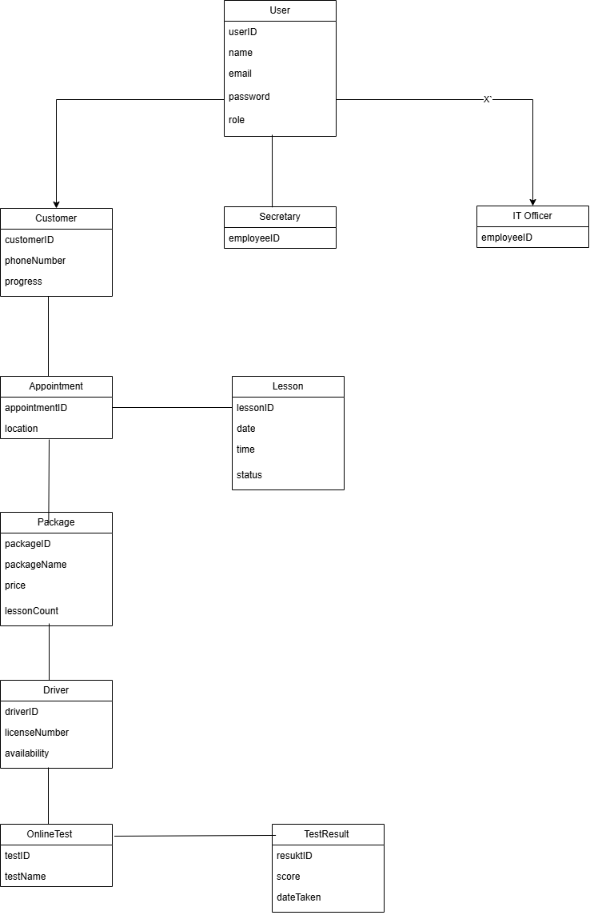

Technical Requirements

Hardware
What this means:
The physical devices needed.
What to write (example):
The DriverPass system will require cloud-based servers to host the application and store user data. Customers and staff will access the system using standard devices such as desktop computers, laptops, tablets, or smartphones with internet access. No specialized hardware is required beyond standard computing devices.

Software
What this means:
Programs needed to run the system.
What to write (example):
The system will operate as a web-based application and will require a modern web browser such as Chrome, Edge, or Firefox. A database management system will be used to store user accounts, lesson schedules, test results, and other system data. The backend application software will handle scheduling, testing, and user management functions.

Tools
What this means:
Support tools used by developers and administrators.
What to write (example):
Development and design tools such as Lucidchart will be used to create and maintain system diagrams. Administrative tools will be required for managing users, lesson schedules, and training packages. Reporting tools may also be used to track customer progress and system usage.

Infrastructure
What this means:
How everything is hosted and connected.
What to write (example):
The DriverPass system will be hosted using a cloud-based infrastructure to ensure scalability and reliability. A secure network connection will be required to protect user data and system communications. Regular data backups and recovery processes will be implemented to prevent data loss and ensure system availability.

